EVENT HORIZON

Use-Case Architecture View

TEAM 7
American University of Sharjah
College of Engineering
Computer Science and Engineering

Date: 23-03-2018

Jayroop Ramesh 57412
Saad Bashar 61382
Zahra Sadat 59068

Version #1: 0000.doc

Table of Content

Use-Case Architecture View 1
Use-Case Architecture View 4
1 Account Management 5
1.1 Use-case Diagram 5
1.2 Use-case Description 6
2 Use-Case Model 13
2.1 Event Management Diagram 13
2.2 Use-case Description 14

Use-Case Architecture View
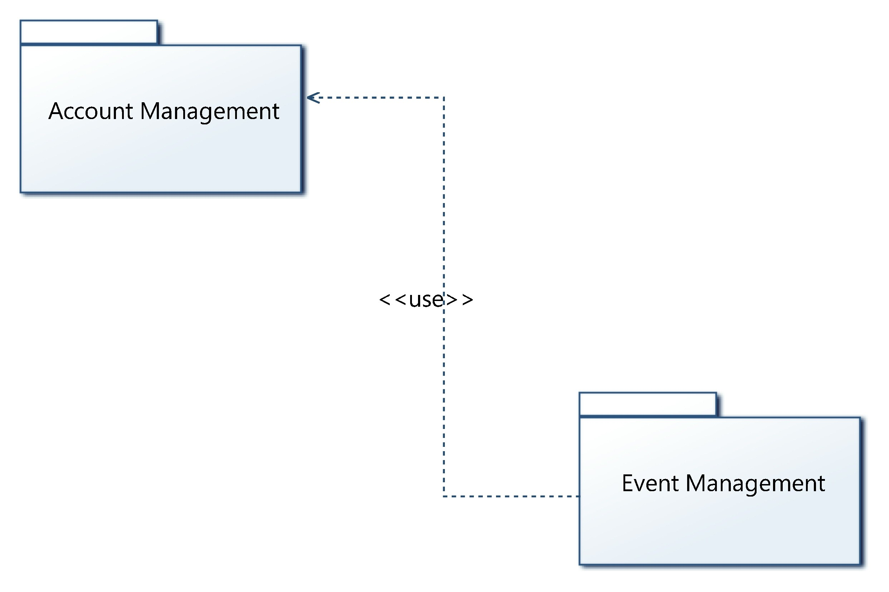
Figure 1: Use-Case Packages

Account Management

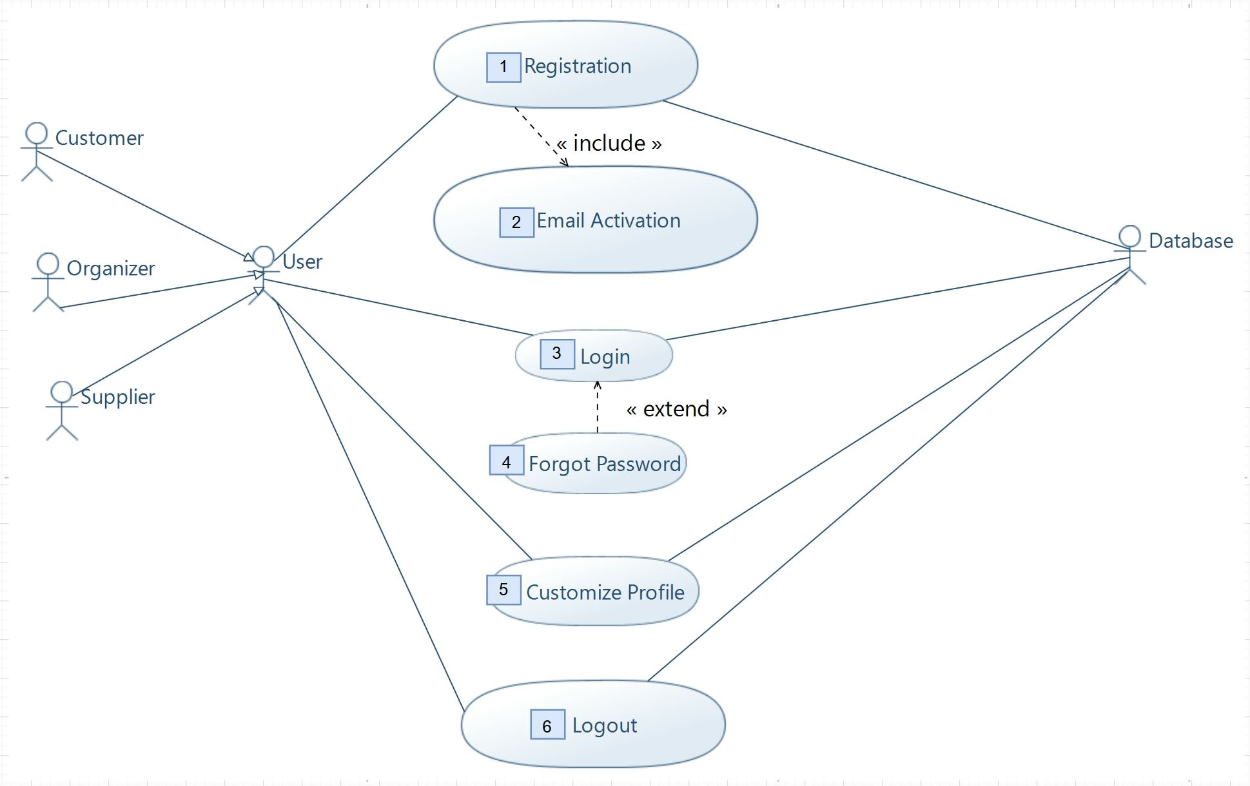
Use-case Diagram
Register User
Activate Email

Figure 2: Account Management Diagram

Use-case Description
Use-Case ID: | AM_1
Use-Case Name: | Registration
Created By: | Jayroop Ramesh | Last Updated By: | Zahra Sadat
Date Created: | 26/03/2018 | Date Last Updated: | 01/03/2018

Actors: | User, Database
Description: | This use case enables the user to create an account and this information is stored in the database.
Preconditions: | The user requests to register.
Postconditions: | The user has an account that awaits activation.
Normal Flow: | AM_1.0: The system prompts the user with a registration form.  AM_1.1: The user will be required to fill details of username, password, email address and an account type to indicate Customer, Organizer or Supplier.  AM_1.2: The system cross-references the inputted information to the database to seek if the user already has an account.  AM_1.3: The system generates a link for activation and sends this to the user provided email if no duplicate accounts are found.  AM_1.4: Includes Activate Email
Alternative Flow: | N/A
Exceptions Flow: | AM_1.1 E.1 The system prompts the user to recheck the fields when the entered details is invalid.  AM_1.2 E.1 The system displays a message informing the user that an account with the same details already exists on the database.
Includes: | AM_2.0: Includes Activate Email
Special Requirements: | - The system is connected to the internet.  - The verification email is sent by system within 5 minutes of user creating an account.  - The system notifies users of any errors in less than 10 seconds.
Assumptions: | The system is connected to the internet and the connection is stable.
Notes and Issues: | N/A

Use-Case ID: | AM_2
Use-Case Name: | Email Activation
Created By: | Jayroop Ramesh | Last Updated By: | Saad Bashar
Date Created: | 26/03/2018 | Date Last Updated: | 01/03/2018

Actors: | N/A
Description: | This use case is regarding the email activation link sent to the email address provided by the user during the registration phase for verification purposes and prevent multiple account creations under the same email address.
Preconditions: | The user has initiated the registration on the system and submitted required details.
Postconditions: | The system activates the account on the database and now will allow user to login and use the system services.
Normal Flow: | AM_2.0: The user receives a mail containing the activation link from the system on their provided email address.  AM_2.1: The user verifies their account by clicking the link.  AM_2.2: The database marks the account as activated giving user the ability to access the system application functionalities.  AM_2.3: The system notifies the user with a pop-up message that his/her account is verified.
Alternative Flow: | N/A
Exceptions Flow: | N/A
Includes: | N/A
Special Requirements: | The user receives the verification email from the system in less than or equal to 5 minutes.
Assumptions: | N/A
Notes and Issues: | N/A

Use-Case ID: | AM_3
Use-Case Name: | Login
Created By: | Saad Bashar | Last Updated By: | Zahra Sadat
Date Created: | 26/03/2018 | Date Last Updated: | 01/03/2018

Actors: | User, Database
Description: | This use case outlines the user logging in to the system with their username/email and password and being able to customize their profiles and use the event management functionalities.
Preconditions: | The user has successfully created an account and been verified on the database.
Postconditions: | The system displays to the user a home screen and their profile can be modified here.
Normal Flow: | AM_3.0: The system prompts the user for their username or email and password.  AM_3.1: The user submits their email or username and password to the system by clicking a login button.  AM_3.2: The system checks if the details entered by the user are consistent with the account stored in database and authenticates the user login.  AM_3.3: If validated, the system returns to the user a home screen where users can proceed to use the event services or choose to customize their profile.
Alternative Flow: | NORMAL FLOW AM_3.0  AM_3.1: Includes Forgot Password.
Alternative Flow: | NORMAL FLOW AM_3.0-3.2  AM_3.3: Includes Forgot Password.
Exceptions Flow: | AM_3.2 E.1 The system notifies the user if no such account with his/her details exist on the database and prompt them to click forgot password.
Includes: | AM_4: Forgot password.
Special Requirements: | - The system is connected to the internet.  - The system notifies users of any errors in less than 10 seconds.
Assumptions: | - The user has an account on the database.  - The user remembers his/her email used for registration for forgot passwords.
Notes and Issues: | N/A

Use-Case ID: | AM_4
Use-Case Name: | Forgot Password
Created By: | Zahra Sadat | Last Updated By: | Jayroop Ramesh
Date Created: | 27/03/2018 | Date Last Updated: | 01/03/2018

Actors: | User, Database
Description: | This use case allows the user to validate their login using their email if they current have forgotten their password.
Preconditions: | The user has a verified account on the database.
Postconditions: | The system allows the user to set a new password and access its services.
Normal Flow: | AM_4.0: The user clicks “forgot password” option displayed on system.  AM_4.1: The system prompts the user to enter their registered email address for account recovery.  AM_4.2: The system generates a verification code.  AM_4.3: The system sends an email with reset instructions and the verification code to the user email provided.  AM_4.4: The system prompts for the verification code.  AM_4.5: The user is required to input the code sent to their email.  AM_4.6: The system prompts the user to enter a new password if code is correct.  AM_4.7: The user enters the new password and clicks submit.  AM_4.8: The system relays this information to the database where the user account details are updated.
Alternative Flow: | N/A
Alternative Flow: | N/A
Exceptions Flow: | AM_4.2 E.1 The system notifies the user to reenter the email if the email provided by user is not on the database.  AM_4.3 E.1 The system alerts the user that verification code is incorrect and to provide the code again.
Includes: | N/A
Special Requirements: | - The system is connected to the internet.  - The system notifies users of any errors in less than 10 seconds.
Assumptions: | - The user has an account on the database.  - The user remembers his/her email used for registration for forgot passwords.
Notes and Issues: | N/A

Use-Case ID: | AM_5
Use-Case Name: | Customize Profile
Created By: | Jayroop Ramesh | Last Updated By: | Zahra
Date Created: | 25/02/2018 | Date Last Updated: | 1/03/2018

Actors: | User, Database
Description: | The user customizes their profile by entering their details.
Preconditions: | - The user must have an account.  - The user must be logged into their account.
Postconditions: | The system updates the database with the details entered.
Normal Flow: | AM_5.0: The user clicks on “Customize Profile”.  AM_5.1: If the user is an event organizer, the profile has: name, logo, list of their previous events, current events, email, types of events they offer. The user can add/delete/modify any of these details.  AM_5.2: The user clicks on “Apply Changes”.
Alternative Flow 1: | NORMAL FLOW AM_5.0  AM_5.1: If the user is an item supplier, the profile has: company name, type of supplies they provide, logo. The user can add/delete/modify any of these details.  AM_5.2: The user clicks on “Apply Changes”.
Alternative Flow 2: | NORMAL FLOW AM_5.0  AM_5.1: If the user is a customer, the profile has: username, display picture, age (optional). The user can add/delete/modify any of these details.  AM_5.2: The user clicks on “Apply Changes”.
Exceptions Flow: | NORMAL FLOW AM_5.0 – AM_5.1  AM_5.1 E.1: If the input type does not match the database constraints, the system prompts the user to use the correct input type.
Includes: | N/A
Special Requirements: | - The system should perform the changes within 10 seconds.
Assumptions: | N/A
Notes and Issues: | N/A

Use-Case ID: | AM_6
Use-Case Name: | Logout
Created By: | Zahra Sadat | Last Updated By: | Saad Bashar
Date Created: | 27/02/2018 | Date Last Updated: | 1/03/2018

Actors: | User, Database
Description: | The user logs out of their account.
Preconditions: | - The user must be logged into their account.  - The user must not be in the middle of a transaction.
Postconditions: | N/A
Normal Flow: | AM_6.0: The user clicks on “Logout”.  AM_6.1: The database connection is closed.  AM_6.2: The user is logged out of their account.  AM_6.3: The user is brought to the default home page.
Alternative Flow: | N/A
Exceptions Flow: | NORMAL FLOW AM_6.0  AM_6.0 E.1: If the user is in the middle of a transaction, the system displays a message asking the user to finish or cancel the transaction before logging out.
Includes: | N/A
Special Requirements: | - The system should perform the logout within 2 seconds.
Assumptions: | N/A
Notes and Issues: | N/A

Use-Case Model

Event Management Diagram
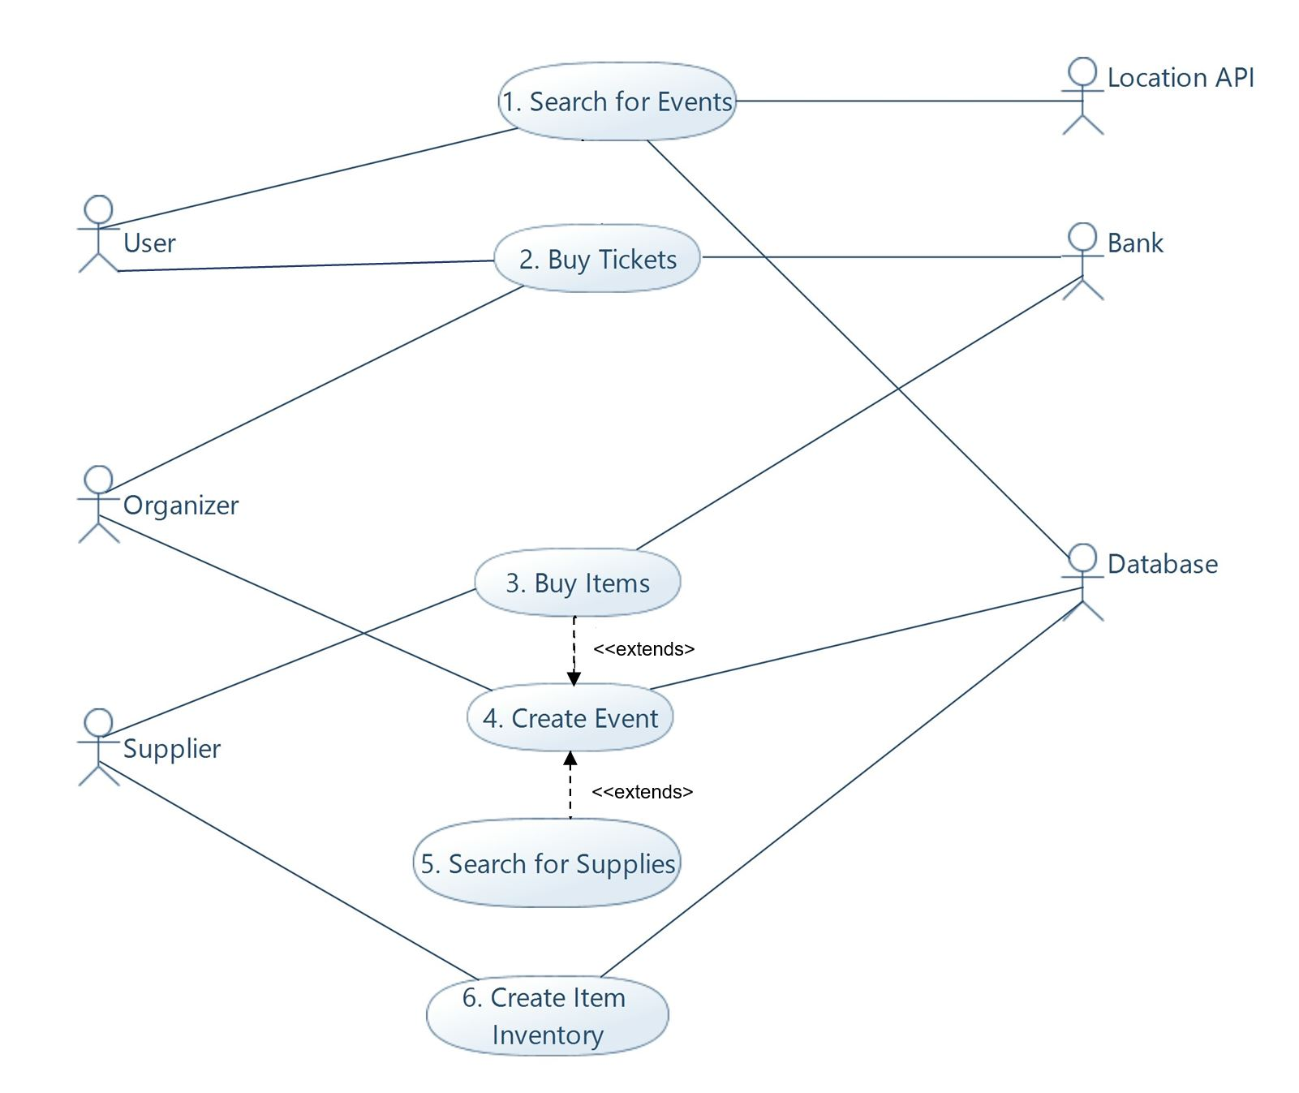
Figure 3: Event Management Diagram

Use-case Description
Use-Case ID: | EM_1
Use-Case Name: | Search for Events
Created By: | Jayroop Ramesh | Last Updated By: | Saad Bashar
Date Created: | 26/02/2018 | Date Last Updated: | 28/02/2018

Actors: | Customer, Location API, Database
Description: | The customer searches for events based on their preferred event type and their address.
Preconditions: | - The customer must be logged into their account.
Postconditions: | N/A
Normal Flow: | EM_1.0: The customer clicks on “Search for Events”.  EM_1.1: The customer chooses their location preference and type preference.  EM_1.2: The customer clicks “Search”.  EM_1.3: The system retrieves results matching the customer’s preferences from the database.  EM_1.4: The system displays a list of events.
Alternative Flow: | N/A
Exceptions Flow: | Normal Flow EM_1.0 - EM_1.2  EM_1.2 E.1: If there are no events with the preferred location and type in the database, the system informs the customer of this and prompts the customer to enter a new location or type.
Includes: | N/A
Special Requirements: | - The user is connected to the internet.  - The system displays the list of events within 2 seconds.  - The system uses Google Maps API to find location of events and customers.
Assumptions: | N/A
Notes and Issues: | N/A

Use-Case ID: | EM_2
Use-Case Name: | Buy Tickets
Created By: | Zahra Sadat | Last Updated By: | Saad Bashar
Date Created: | 27/02/2018 | Date Last Updated: | 28/02/2018

Actors: | Bank, Customer, Organizer, Database
Description: | The customer buys tickets for a certain event from the organizer through the bank.
Preconditions: | - The customer must be logged into their account.  - The customer must choose an event and open the event page via the “Search for Events” use case or the home page.
Postconditions: | The database updates the number of tickets available for that event.
Normal Flow: | EM_2.0: The customer chooses how many tickets they want.  EM_2.1: The customer clicks on the “Buy” button.  EM_2.2: The customer enters their card number, card expiration date, card holder name, card cvv2 number.  EM_2.3: The system connects to the bank and performs the transaction between the customer and the event organizer.  EM_2.4: If successful, the system informs the customer that the transaction has succeeded.  EM_2.5: The system sends the ticket to the customer via email.
Exceptions Flow 1: | Normal Flow EM_2.0 - EM_2.3  EM_2.4 E.1: If transaction not successful, the system prompts the customer to enter the details again.
Exceptions Flow 2: | Normal Flow EM_2.0 – EM_2.3  EM_2.3 E.1: If the connection to the bank fails, the system asks the user to try again in a few minutes.  EM_2.3 E.2: If all available tickets are sold out before the transaction is finished, the system displays a message to inform the customer and displays a list of events with similar types and locations.
Includes: | N/A
Special Requirements: | - The system should respond to errors within 10 seconds.  - The system should support Visa and MasterCard payment.  - The customer’s card details should be protected.
Assumptions: | N/A
Notes and Issues: | N/A

Use-Case ID: | EM_3
Use-Case Name: | Buy items
Created By: | Saad Bashar | Last Updated By: | Jayroop Ramesh
Date Created: | 28/2/2018 | Date Last Updated: | 1/3/2018

Actors: | Organizer, Bank
Description: | This use case allows the organizer to book an event by paying for it.
Preconditions: | The organizer has selected the venue and supplies necessary for the event and displayed to user the price.
Postconditions: | The event is booked.
Normal Flow: | EM_3.0: The organizer clicks on the “Make Payment” button.  EM_3.1: The system prompts the user to enter their credit card details of card number, card expiration date, card holder name, card cvv2 number.  EM_3.2: The system sends the credit details with the amount for payment to the bank for payment.  EM_3.3: If transaction is successful the bank sends the system a notification indicating the same.  EM_3.4: The system sends a notification to organizer that the payment has been made.  EM_3.5: The system sends the supplier a notification about the service or supplies requested by the organizer.
Alternate Flow: | NORMAL FLOW EM_3.0 - EM_3.3  EM_3.4: If transaction not successful, the bank notifies the system.  EM_3.5: The system displays a notification to the user that payment has failed.  EM_3.6: The system prompts the user to remake the payment or provides the option to cancel the session.
Exceptions Flow: | EM_3.4 E1.1 If the details are inaccurate, the bank sends a notification to the system.  EM_3.4 E1.2 The system asks the user to check their card or bank transaction details.  EM_3.4 E1.3 If the details are entered incorrectly 3 times, the system times out the organizer’s account for 30 minutes and sends the organizer an email to check their card/account details.
Includes: | N/A
Special Requirements: | - The user is connected to the internet.
Assumptions: | N/A
Notes and Issues: | N/A

Use-Case ID: | EM_4
Use-Case Name: | Create Event
Created By: | Saad Bashar | Last Updated By: | Zahra Sadat
Date Created: | 28/2/2018 | Date Last Updated: | 1/3/2018

Actors: | Organizer, Database
Description: | This use case allows the organizer to collect venues and items to create an event.
Preconditions: | The organizer searches for the event venue and supplies.
Postconditions: | The event is booked.
Normal Flow: | EM_4.0: The organizer clicks on the create event button.  EM_4.1: The system prompts the user to enter event details of name, date, type, ticket price (optional) and location.  EM_4.2: The system updates the database to add the event to the organizer’s booked events tab.
Alternative Flow: | NORMAL FLOW EM_4.0 - EM_4.1  EM_4.2: Extended by Search for Supplies  EM_4.3: The system calculates cost for the supplies selected.  EM_4.4: The system displays to user the total cost to pay for the supplies.  EM_4.5: Extended by Buy Items  EM_4.6: NORMAL FLOW EM_4.2
Exceptions Flow 1: | EM_4.3 E1 If the filters set by the user have any illogical or illegal values, the system shows them an error message.
Exceptions Flow 2: | EM_4.7 E2.1 If payment is not successful, the system sends the user an error message.  EM_4.7 E2.2 The system prompts the user to attempt the payment again.
Includes: | N/A
Special Requirements: | - The user is connected to the internet.
Assumptions: | N/A
Notes and Issues: | N/A

Use-Case ID: | EM_5
Use-Case Name: | Search for Supplies
Created By: | Saad Bashar | Last Updated By: | Jayroop Ramesh
Date Created: | 28/2/2018 | Date Last Updated: | 1/3/2018

Actors: | Organizer, Database
Description: | This use case allows the organizer to search for venues and supplies before collecting them in the “Create Event” use case.
Preconditions: | The organizer is on the “create event” screen returned by the system.
Postconditions: | The list of matching venues and suppliers is shown by the system.
Normal Flow: | EM_5.0 The organizer clicks on the “Search” button.  EM_5.1 The system shows the organizer the search screen along with additional filters such as: location, capacity, services provided, dates available and cost per unit.  EM_5.2 The organizer types in search terms and selects appropriate filters.  EM_5.3 The organizer clicks on the “Run Search” button.  EM_5.4 The system sends a query with the search terms and appropriate filters to the database.  EM_5.5 The database runs the query and sends the result set back to the system if exists.  EM_5.6 The system displays the result set to the organizer.  EM_5.7 The organizer can add supplies to their event.
Alternative Flow: | NORMAL FLOW EM_5.4 - EM_5.5  EM_5.6 If the system detects that the database has sent back an empty set.  EM_5.7 The system prompts the organizer to run the search again with different parameters.  EM_5.8 NORMAL FLOW EM_5.7.
Exceptions Flow 1: | EM_5.4 E1.1 If the system detects that the organizer has input wrong filter parameters such as: illegal symbols or characters in fields or incorrect limits like as a “Maximum cost” that is lower than the “Minimum cost”.  EM_5.4 E1.2 The system shows the organizer a warning that their search parameters may be wrong on the screen.  EM_5.4 E1.3 The system highlights the wrong search parameters.  EM_5.4 E1.4 The system blocks the organizer from running the search until the wrong parameters are corrected.
Includes: | N/A
Special Requirements: | - The user is connected to the internet.  - The system displays the list of events within 2 seconds.
Assumptions: | N/A
Notes and Issues: | N/A

Use-Case ID: | EM_6
Use-Case Name: | Create Item Inventory
Created By: | Zahra Sadat | Last Updated By: | Jayroop Ramesh
Date Created: | 28/2/2018 | Date Last Updated: | 1/3/2018

Actors: | Supplier, Database
Description: | This use case allows the supplier to add a list of available services to their inventory.
Preconditions: | The supplier is logged in.
Postconditions: | The inventory list of the supplier is created/updated.
Normal Flow: | EM_6.0 The supplier clicks on the “Create/Update Inventory” button.  EM_6.1 If supplier chooses to create inventory, the supplier is prompted by the system to select items they would like to add; venue or service or supplies.  EM_6.2 The system prompts the supplier to input details of location, capacity, services provided, dates available and cost per unit.  EM_6.3 The supplier is required to click on “Finish”.  EM_6.4 The system sends this information to the database.  EM_6.5 Upon successful addition of this information, the database sends a confirmation to the system.  EM_6.6 The system notifies the supplier the inventory has been created.
Alternative Flow 1: | NORMAL FLOW EM_6.0  EM_6.1 If the supplier chooses to update inventory, the system retrieves the current inventory from the database.  EM_6.2 The system displays the retrieved inventory to the supplier.  EM_6.3 The supplier is required to select which entry he/she wants to update or add a new entry.  EM_6.4 The system shows the details of the item and allows the supplier to make any edit them.  EM_6.5 The supplier makes the changes and clicks on “Save”.  EM_6.6 The system sends the updated information to the database.  EM_6.7 Upon successful updating of the inventory, the database sends a confirmation to the system.  EM_6.8 The system shows the supplier a message to confirm that their inventory has been updated.
Exceptions Flow 1: | EM_6.3 E1.1 If the database sends an empty set, the system detects that no lists exist.
Exceptions Flow 2: | EM_6.3 E2.1 If the database cannot create a table, the system is notified.  EM_6.3 E2.2 The system prompts the user to login later and create an inventory list.
Includes: | N/A
Special Requirements: | - The user is connected to the internet.
Assumptions: | N/A
Notes and Issues: | N/A

